**Insert Client Logo**



**Direct Administrator User Guide**

**Release 5.14.0**

**November 2014**

# INTRODUCTION

Direct Messaging is a method for secure transmission of protected health information (PHI) over the Internet. Direct messaging:

* allows users to communicate with other users within their own HIE and other health information networks
* provides an integrated directory to easily find users in the same network
* offers the ability to delegate a mailbox to another Direct user to send/receive messages for a different account.

Specifics about using the Direct messaging system can be found in the “Direct Messaging User Guide”.

This Direct Administrator User Guide focuses on the webclient tools available for setting up the Direct environment, including the creation of Direct domains, managing digital certificates, and creating user associations to the Direct environment.

# Direct Administration

The Direct Administration features can be accessed by clicking **Direct Administration** on the webclient dashboard. There is also a link to Direct Administration in the **Administration** menu on the navigation bar.

The **Direct Administration** tab of the Direct Administration screen gives quick access to all of the tools needed to manage Direct domains.

On the Direct Administration main screen, you will see a list of all current Direct domains that are associated with the HIE. Each domain will have a separate dashboard, showing the details of that domain. Multiple dashboards can be seen by scrolling down.

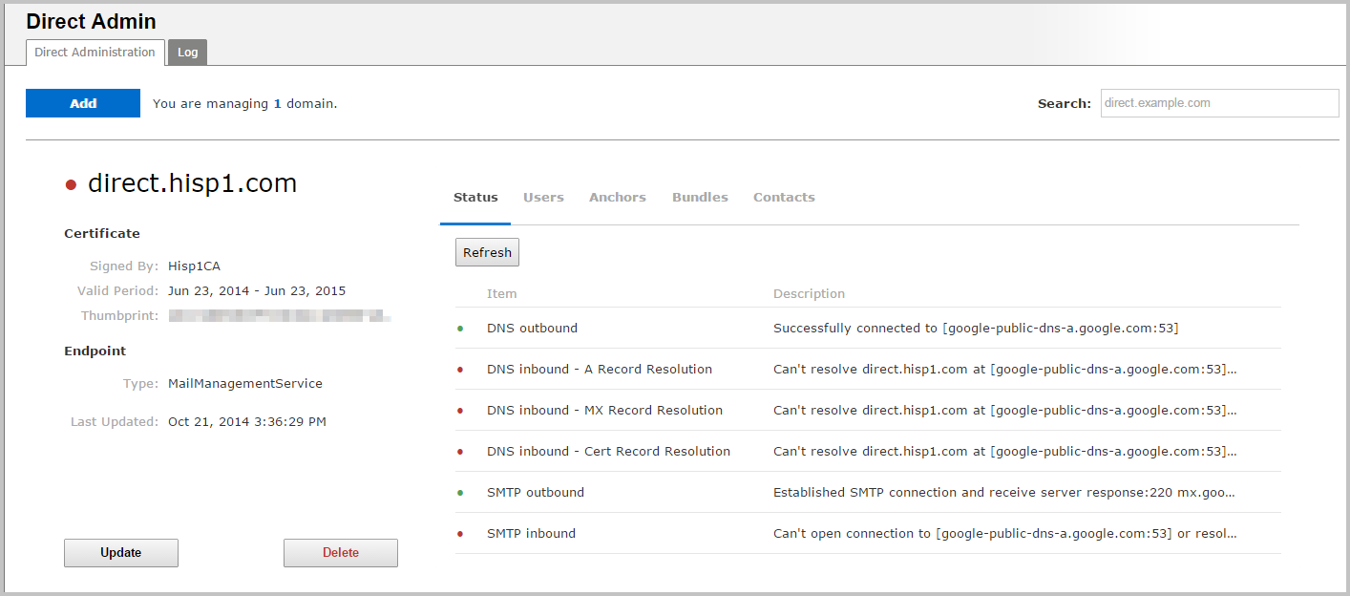

## Domain Dashboards

General information about a Direct domain is available at the left of each domain dashboard.

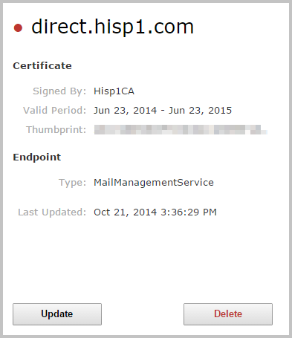

This part of the dashboard shows basic information about the domain, including:

* the domain the certificate was issued to, the Certificate Authority which signed the certificate
* the certificate’s dates of validity
* the certificate’s thumbprint—a string of characters generated from the certificate that is unique to that certificate

Information about the endpoint type is listed in the section below. At the bottom of the general info panel, there buttons which allow the domain’s certificate to be updated, or to delete the domain entirely.

To the right of the domain’s general info panel, there are five tabs which contain more detailed information about the domain. Each tab can be selected by clicking it or hovering the mouse over it.

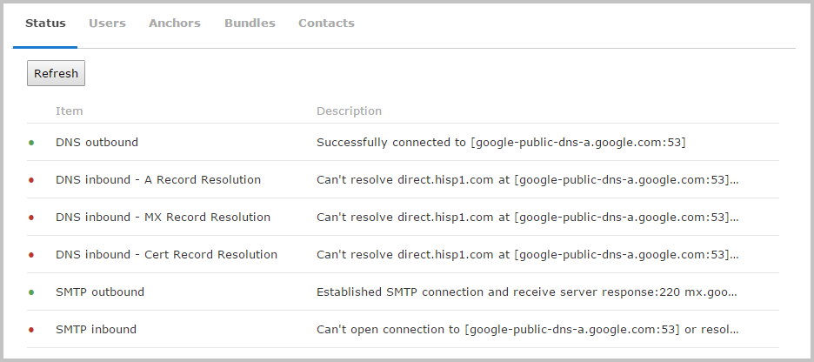

The available tabs include:

* **Status:** shows information about the status of various domain connections.
* **Users:** allows management of user groups associated with the domain.
* **Anchors:** allows management of the Certificate Authority enforcing the domain’s digital certificate.
* **Bundles:** allows management on any trust bundles (groups of trust anchor certificates) used by the domain.
* **Contacts:** Displays which Direct addresses are associated with the domain.

The following sections describe each of the domain dashboard tabs in more detail:

### Status:

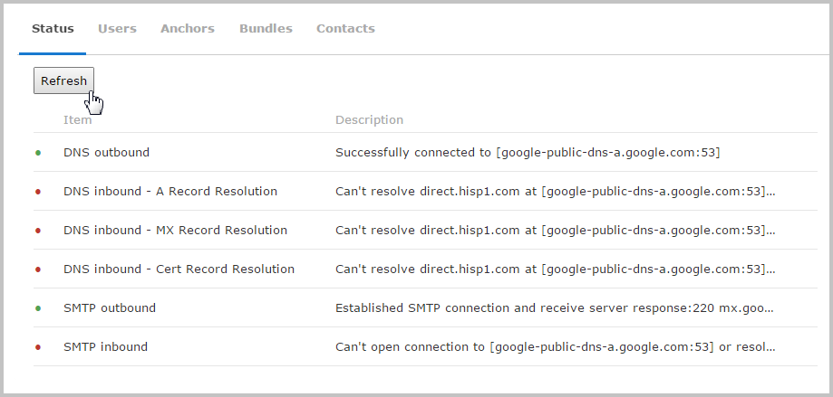

The **Status** tab shows basic status information about Direct domain’s DNS and STMP connections. It monitors 6 different items that can be used to diagnose problems with the direct domain.

Each item on the **Status** tab begins with a small indicator light. If the connection is functional, the light will appear green; if there is a current issue, it will appear red.

Click the **Refresh** button in the upper left to check the current status. Details about the connection’s status are listed in the right-hand column.

### Users:

The **Users** tab simply displays the domain’s endpoint type. Endpoint type is determined when the domain is added to the HIE, and it can be one of three types:

* Mail Management Service
* Enterprise Gateway
* Task System

See the “Adding Direct Domains” section for more information.

### User Groups:

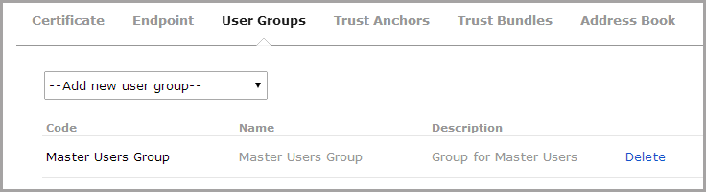

The **User Group** tab allows the user groups to be added to or deleted from the Direct domain. User groups are defined in the **User Security** section of the webclient’s administrative section.

New groups can be added by selecting the desired group from the dropdown box. Once selected, they will appear in a list. Added groups can be removed from the domain by clicking on **Delete**.

### Trust Anchors:

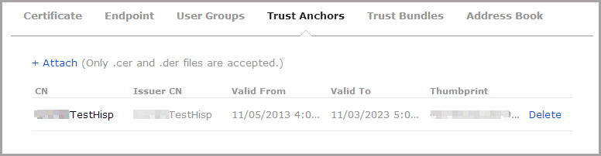

The **Trust Anchors** tab lists all of the Certificate Authorities that are trusted by this domain.

A Trust Anchor’s certificate can be added to the domain by clicking on **Attach**, and then choosing the appropriate certificate file. Only .CER or .DER certificate files ca be added. Trust Anchors can be removed from the domain by clicking on **Delete.**

### Trust Bundles:

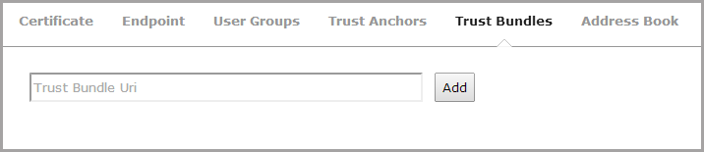

The **Trust Bundle** tab allows collections of trust anchors to be included in the domain. To add a trust bundle, type the appropriate URI in the *Trust Bundle Uri* box and click **Add**.

### Address Book:

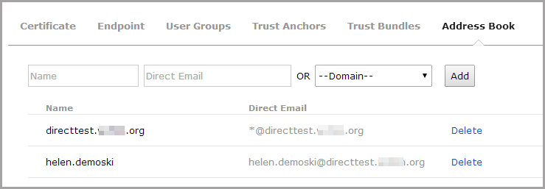

The **Address Book** tab allows Direct addresses to be associated with a specific domain.

To add an individual Direct address, type a user’s name in the *Name* box, the user’s Direct address in the *Direct Email* box, and then click **Add**. The name and address will appear in the Address Book list.

Note: Direct addresses entered in this way are not verified—any text can be entered in the *Name* or *Direct Email* boxes.

To add all users from a Direct domain, choose a selection from the *Domain* dropdown and click **Add**. Now, all users from that domain will be associated with the current dashboard’s domain.

Once Direct user addresses or outside domains are added to the address book, they will be valid recipients for Direct users of this domain. This also means that recipients in the address book will appear as autocomplete suggestions when typed into the address fields when composing messages.

### Adding Direct Domains

To begin adding Direct Messaging functionality to the HIE, a Direct domain must be added to the system. Multiple domains can be added to a single HIE. Each domain will appear as a separate dashboard on the **Direct Administration** main page.

To add a Direct domain, click on the **Add new domain** button at the top of the screen.

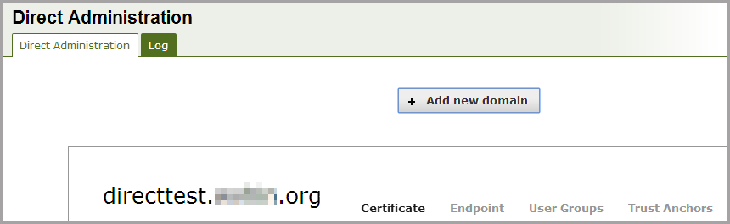

The *Add New Domain* window will appear.

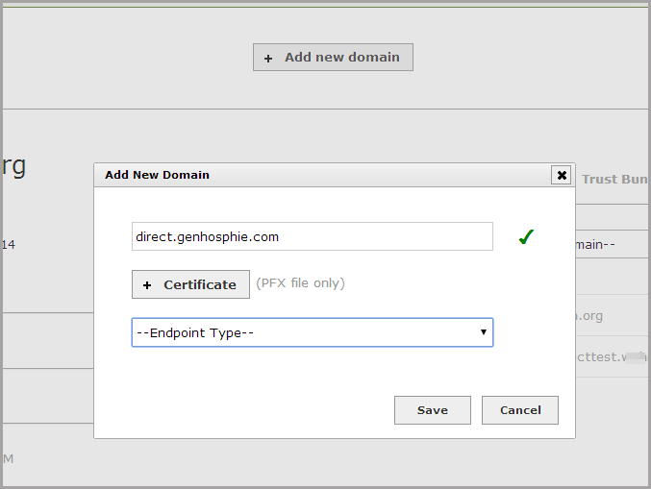

Type the domain in the box provided. The domain’s certificate can be added by clicking on the **Certificate** button and selecting the appropriate .PFX file.

Choose the domain’s endpoint type from the **Endpoint Type** dropdown. Endpoints can be one of three types:

* **Mail Management Service**
* **Enterprise Gateway**
* **Task System**

Once all the required information has been added, click **Save**. A dashboard for the domain will now appear on the main Direct Administration page.

### Direct Administration Log

The **Log** tab on the Direct Administration screen allows a number of auditing and diagnostic measures to be reviewed.

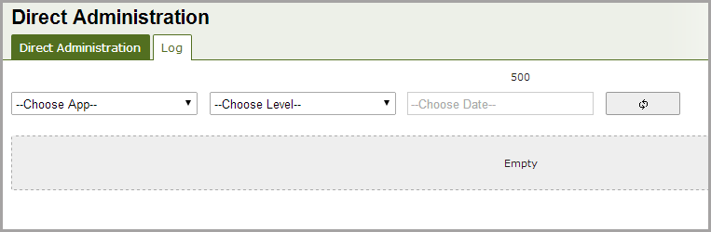

Click on the **Choose App** dropdown to select an area of information. Selections include:

* **Direct Agent**
* **Direct Relay**
* **Enterprise Gateway**
* **James Host**
* **Mail Management**
* **Mail Proxy**

Click on the **Choose Level** dropdown to select the type of log information to be viewed about an area. Selections include:

* **Debug**
* **Error**
* **Information**
* **Unspecified**
* **Warning**

Finally, type in the desired date for log information in the *Choose* Date box, or select a date from the calendar tool.